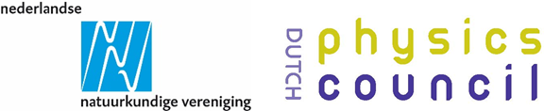
Minerva Prize

Nomination Form

Nominations for the DPC/NNV Minerva Prize 2023 should be sent to directeur@nnv.nl by 1 October 2023 at the latest. If you have questions about the prize or nomination form, please contact the secretaries of the award:
Arlette Werner (DPC), via a.werner@nwo.nl
Noortje de Graaf (NNV), via directeur@nnv.nl

I - General information:

Contact details
Information of the nominee |  | Information of the nominator (if different from nominee)
Name: |  | Name:
Affiliation: |  | Affiliation:
E-mail: |  | E-mail:
Tel.: |  | Tel.:
Date MSc diploma*:
MSc | <specify research field>
* 1) or an equivalent of a MSc diploma;
2) Should be after 1 October 2012. Note, extension of the 10-year professional life period can be applicable, if well-motivated (and positively assessed by the jury).

If of relevance, please add your motivation for extension of the 10-year professional life period:
…

Summary
Summarize the nomination in a maximum of 100 words:
…

II – Motivational letter by the nominator (max 2 pages)

Please motivate why you think the nominee should be considered as the most outstanding young female or non-binary physicist currently in the Netherlands and should win the Minerva Prize. You have to explicitly address the two assessment criteria as listed on the Rules & Guidelines of this prize when describing why the candidate scientifically excels.

…….

III – CV of the nominee (max 1.5 page)

IV – Letter of support (only required in case of a self-nomination)
In case of a self-nomination, you are required to seek for at least one letter of support from an expert. Such an expert will be well regarded in the appropriate field, familiar with the work of the nominee and be able to comment on the scientific impact of the candidate.

